Moderation Analysis Worksheet (PROCESS Model 1)
Scenario
A study examines how trauma exposure relates to delinquent behavior among children involved in the child welfare system. Researchers are particularly interested in whether this relationship differs depending on whether a child has experienced neglect.
You will use the dataset:
pts vex mod mediation.SAV
Variables
- X (Predictor): tra1 = Trauma exposure (continuous)
- W (Moderator): negever = Neglect (0 = No neglect, 1 = Neglect)
- Y (Outcome): bcdel1 = Delinquent behavior (continuous)
Analysis Instructions
Run a moderation analysis using PROCESS macro for SPSS with the following specifications:
- Model = 1
- Y = bcdel1
- X = tra1
- W = negever

Part 1: Research Question
State the research question:

Part 2: Hypotheses
H1 (Main effect of trauma):

H2 (Main effect of neglect):

H3 (Moderation hypothesis):

Part 3: Extracting Results from PROCESS Output
1. Model Fit
- $R^{2}=$__________
- $F(df_{1},df_{2})=$__________
- $p=$__________
Interpretation (1 sentence):

2. Main Effect of Trauma (tra1)
- $b=$__________
- $p=$__________
Fill in the sentence:
For children without neglect, a one-unit increase in trauma is associated with a __________ (increase/decrease) in delinquent behavior.
Interpretation:

3. Main Effect of Neglect (negever)
- $b=$__________
- $p=$__________
Fill in the sentence:
Children who have experienced neglect have __________ (higher/lower) delinquent behavior compared to those without neglect.
Interpretation:

4. Interaction Effect (tra1 × negever)
- $b=$__________
- $p=$__________
Fill in the sentence:
The interaction is __________ (significant/not significant), indicating that the relationship between trauma and delinquent behavior __________ (does/does not) depend on neglect.
Interpretation:

Part 4: Conditional Effects
From the PROCESS output, locate the section:
“Conditional effects of the focal predictor”
Report:
- Effect of trauma when negever = 0: __________
- Effect of trauma when negever = 1: __________
Fill in:
For children without neglect, trauma __________ delinquent behavior.
For children with neglect, trauma __________ delinquent behavior.
Part 5: Visualization
Draw the interaction plot
On the axes below:
- X-axis = Trauma (tra1)
- Y-axis = Delinquent behavior (bcdel1)
Draw TWO lines:
- Line 1: No neglect (negever = 0)
- Line 2: Neglect (negever = 1)
Label which line is steeper.
📝 Interpretation:

Why is a Johnson–Neyman analysis NOT appropriate in this model?
Answer:

Think about the type of variable W (negever) is.
Final Interpretation (Write 3–4 sentences)

Now run moderation_example_r.R to get the following plot, super cool!
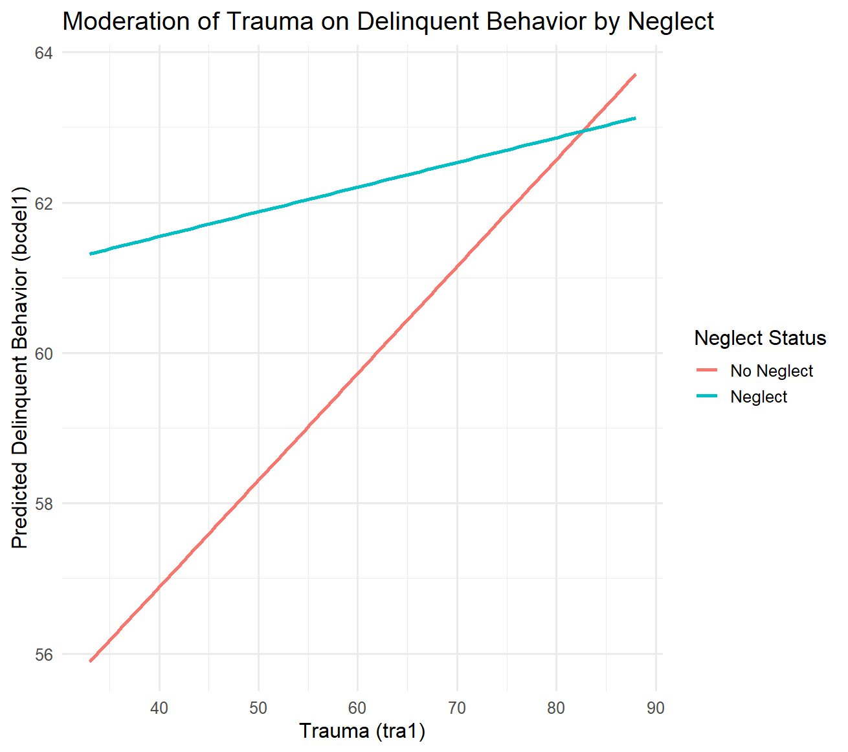

Now redo this using cidi1 as Moderator (cidi1 is a continuous score of depressive symptoms). Here is what I found – super fascinating!!
Effect moderation of internalizing on the association between trauma exposure and delinquent behavior
A moderation analysis was conducted to examine whether internalizing distress (cidi1) moderates the association between trauma exposure (tra1) and delinquent behavior (bcdel1) using PROCESS Model 1. The model was statistically significant, $F(3,1905)=39.58,p<.001$, explaining 5.87% of the variance in delinquent behavior ($R^{2}=.0587$) . Trauma exposure was positively associated with delinquent behavior ($b=0.2468,p=.0035$), indicating that higher levels of trauma correspond to higher levels of delinquency. Internalizing distress was also a significant positive predictor ($b=0.4502,p<.001$), suggesting that higher distress is associated with increased delinquent behavior.
Importantly, the interaction between trauma and internalizing distress was statistically significant ($b=-0.0047,p=.0027$), indicating that the effect of trauma on delinquent behavior depends on (or is conditioned by) levels of internalizing distress. Conditional effects analyses revealed that trauma was a significant positive predictor of delinquent behavior at low levels of internalizing distress ($b=0.0631,p=.0379$), but this effect was no longer statistically significant at moderate levels ($b=0.0301,p=.2192$) and became negative, though not statistically significant, at higher levels ($b=-0.0406,p=.1304$). These results suggest that trauma is most strongly associated with delinquent behavior among individuals with relatively low levels of internalizing distress.
Johnson–Neyman analyses further clarified this pattern by identifying regions of significance across the continuum of internalizing distress. The effect of trauma on delinquent behavior was significantly positive at lower levels of distress (below approximately 40.29), non-significant across moderate levels (approximately 40.29 to 65.25), and significantly negative at higher levels of distress (above approximately 65.25) . This pattern indicates a crossover interaction in which trauma increases delinquent behavior at low levels of distress but is associated with reduced delinquency at high levels of distress. This is demonstrated in the following plots and analysis.
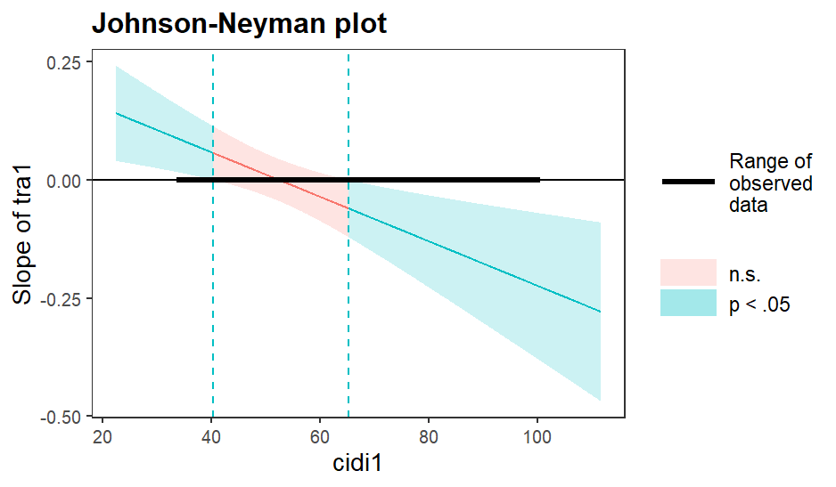
Notes the line is at 0 so the effect of trauma on delinquent behavior is positive at low cidi and negative at high values of cidi. When cidi1 is OUTSIDE the interval [40.29, 65.25], the slope of tra1 is p < .05.
Conditional effect of focal predictor at values of the moderator:
cidi1 Effect se t p LLCI ULCI
34.0000 .0866 .0360 2.4032 .0163 .0159 .1573
37.4737 .0703 .0320 2.1958 .0282 .0075 .1330
40.2942 .0570 .0290 1.9612 .0500 .0000 .1139
40.9474 .0539 .0284 1.8963 .0581 -.0018 .1096
44.4211 .0375 .0255 1.4709 .1415 -.0125 .0875
47.8947 .0212 .0235 .8994 .3685 -.0250 .0673
51.3684 .0048 .0227 .2110 .8329 -.0397 .0493
54.8421 -.0116 .0232 -.4999 .6172 -.0570 .0338
58.3158 -.0279 .0248 -1.1251 .2607 -.0766 .0208
61.7895 -.0443 .0275 -1.6108 .1074 -.0982 .0096
65.2471 -.0606 .0309 -1.9612 .0500 -.1212 .0000
65.2632 -.0607 .0309 -1.9626 .0498 -.1213 .0000
68.7368 -.0770 .0348 -2.2109 .0272 -.1454 -.0087
72.2105 -.0934 .0391 -2.3863 .0171 -.1702 -.0166
75.6842 -.1098 .0437 -2.5122 .0121 -.1955 -.0241
79.1579 -.1261 .0484 -2.6044 .0093 -.2211 -.0311
82.6316 -.1425 .0533 -2.6733 .0076 -.2470 -.0380
86.1053 -.1589 .0583 -2.7259 .0065 -.2732 -.0446
89.5789 -.1752 .0633 -2.7669 .0057 -.2994 -.0510
93.0526 -.1916 .0684 -2.7993 .0052 -.3258 -.0574
96.5263 -.2080 .0736 -2.8254 .0048 -.3523 -.0636
100.0000 -.2243 .0788 -2.8466 .0045 -.3789 -.0698

